Department of Electronics and Computing
Study Programme: Applied Electronics


Verification Project
Smart Lamp Controller

Table of Contents
1 The digital design of the circuit 4
1.1 Block Diagram 4
1.2 Description of the general functionality of the DUT (Device Under Test) 4
1.3 DUT Interfaces 5
1.4 List of DUT Functionalities 6
1.5 Schematic Diagram 7
1.6 Waveforms 7
2 Digital Circuit Verification 9
2.1 Verification Environment Architecture 9
2.1.1 Sensor Agent 9
2.1.2 Sensor Transaction 10
2.1.3 Sensor Driver 10
2.1.4 Sensor Monitor 10
2.1.5 Sensor Coverage Collector 10
2.1.6 Sensor Sequences 10
2.1.7 Lamp Agent 11
2.1.8 Lamp Transaction 11
2.1.9 Lamp Monitor 11
2.1.10 Lamp Coverage Collector 11
2.1.11 Button Agent 11
2.1.12 Button Transaction 11
2.1.13 Button Driver 11
2.1.14 Button Monitor 12
2.1.15 Button Coverage Collector 12
2.1.16 Button Sequences 12
2.1.17 Scoreboard 12
2.1.18 Scoreboard Coverage Collector 13
2.2 Verification Checklist 13
2.2.1 Assertions 13
2.3 Functional Coverage Elements 13
2.4 Verification Scenarios and Tests 15
2.5 Results 16

The digital design of the circuit
Block Diagram
General Functionality Description of the DUT (Device Under Test)
DUT Interfaces
List of DUT Functionalities
Schematic Diagram
Waveforms
Register Table

Block Diagram

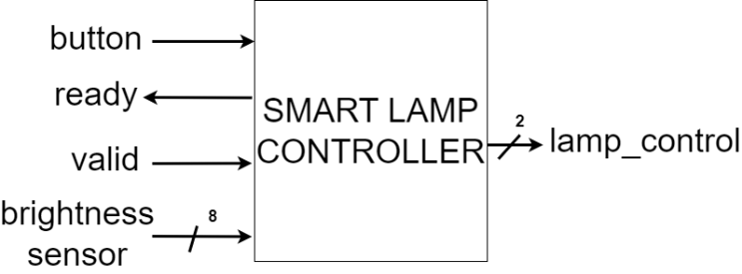
Figure 1. Block diagram of the Smart Lamp Controller

Description of the general functionality of the DUT (Device Under Test)
The DUT controls the light intensity of a lamp. Its functionality depends on two modes: manual mode and automatic mode. The initial state of the lamp is off. A short press from this state switches directly to automatic mode, and a long press when the lamp is off, switches to manual mode. The lamp switches between the two modes by long pressing its button for minimum 20 clock cycles.
In manual mode, the light intensity changes between 4 states by short pressing the button for less than 20 clock cycles, starting with the lamp switched off. In automatic mode, the DUT changes the light intensity based on the values received from a light sensor. The DUT has 4 pre-defined ranges, representing the lamp illumination steps. The sensor data is transmitted using the valid-ready protocol. The DUT only receives the value from the sensor when the valid signal is active. When the valid is not active, the DUT keeps the previously read value.

DUT Interfaces
Table 1. System signals generated in the testbench
General Signals
Signal Name | I/O | Size | Description
clk | I | 1 | Clock signal
reset | I | 1 | Asynchronous reset, active low

Table 2. Sensor Interface
Sensor Interface
Signal Name | I/O | Size | Description
brightness | I | 8 | Environmental brightness
valid | I | 1 | Valid signal
ready | O | 1 | Ready signal

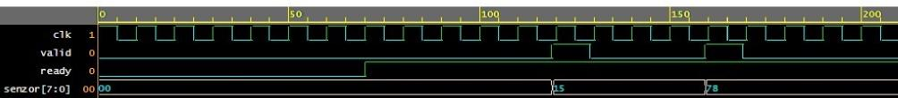
Figure 2. Valid-ready protocol
Table 3. Button Interface
Button Interface
Signal Name | I/O | Size | Description
button | I | 1 | For changing modes and states, active low

Table 4. Lamp Interface
Lamp Interface
Signal Name | I/O | Size | Description
lamp_control | O | 2 | Lighting thresholds

List of DUT Functionalities

- Reads button state
- Counts the number of clock cycles when the button is pressed
- Receives environmental brightness from light sensor in automatic mode
- Calculates lamp’s light intensity based on press length and sensor data

Table 5. Brightness ranges
Light Intensity | Sensor Values Range | DUT Output Value
On 2 | 0-63 | 11
On 1 | 64-127 | 10
On 0 | 128-191 | 01
Off | 192-255 | 00

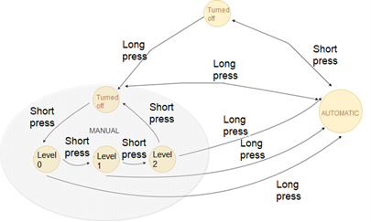
Figure 3. Finite State Machine describing the functionality of the smart lamp

Schematic Diagram

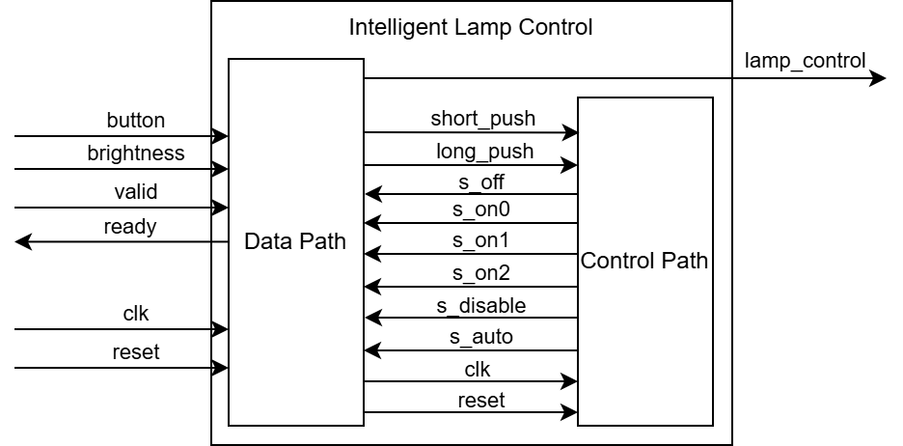
Figure 4. DUT Block Diagram

Table 6. Internal signals of DUT
Signal name | Description
short_push | Indicates that the button has been pressed short
long_push | Indicates that the has been pressed long
s_off | Indicates that the DUT is in the OFF state, lamp is off.
s_on0 | Indicates that the DUT is in ON0 state.
s_on1 | Indicates that the DUT is in ON1 state.
s_on2 | Indicates that the DUT is in ON2 state.
s_disable | Indicates that the DUT is turned off.
s_auto | Indicates that the DUT is in the Automatic mode.

Waveforms
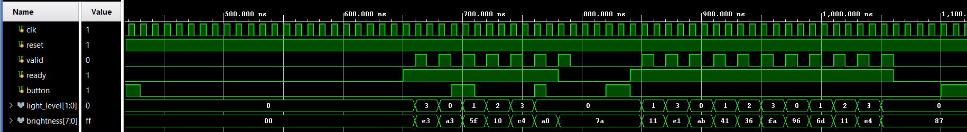
Figure 5. Waveforms from the DUT in automatic mode

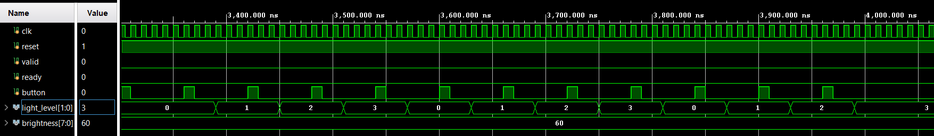
Figure 6. Waveforms from the DUT in manual mode

2 Digital Circuit Verification
Verification Environment Architecture
Verification Checklist
Functional Coverage Elements
Verification Scenarios
Tests Results

Verification Environment Architecture
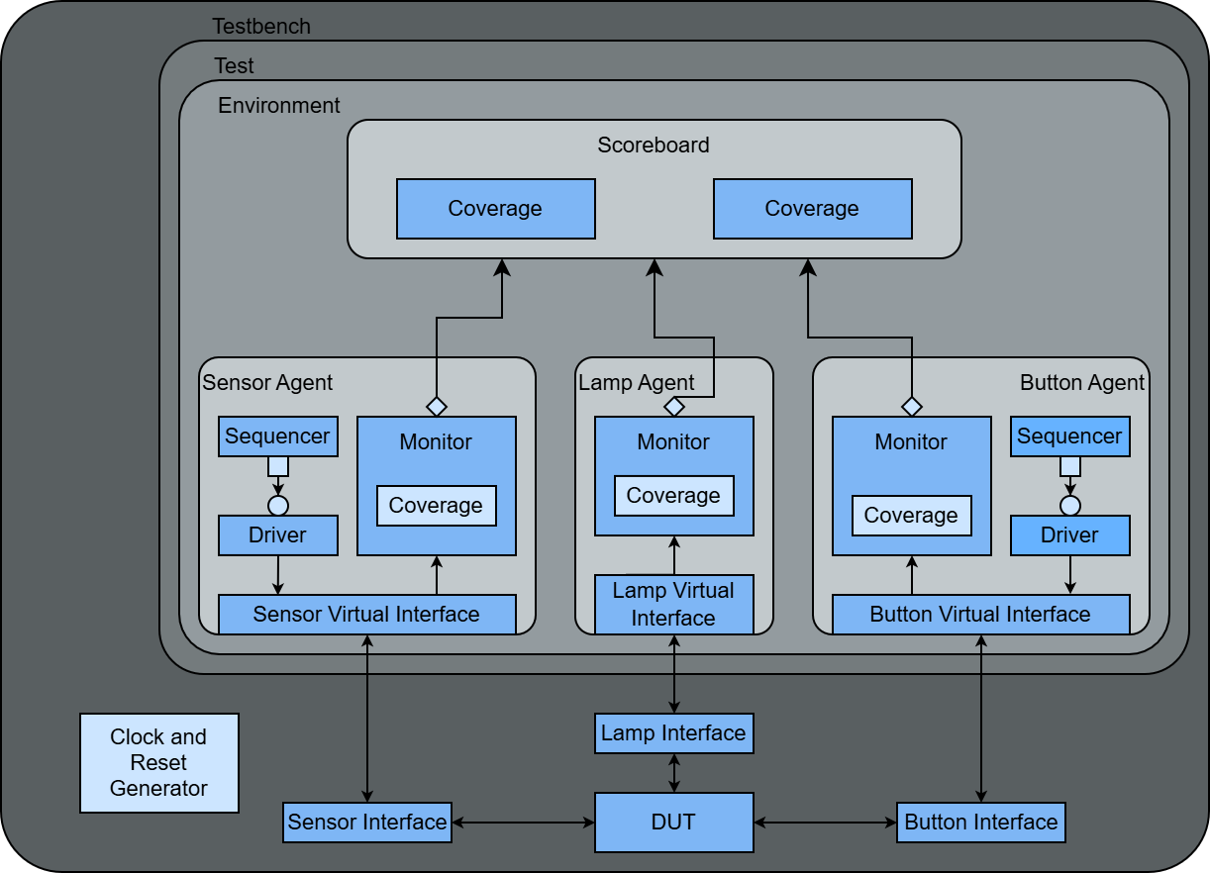
Figure 7. Overview of the components necessary for sending stimuli to the DUT

Sensor Agent
The Sensor Agent is an active agent that encapsulates the Sequencer, Driver and Monitor into a single entity, connecting the components with the DUT using the virtual interface.

Sensor Transaction
Table 7. Sensor Transaction
Field Name | Type | Size | Values | Description
sensor | rand bit | 8 | [0:255] | Value of environmental brightness

Sensor Driver
The Sensor Driver interacts with the DUT via the Sensor Interface, sending the transactions generated by the Sensor Sequencer. The transactions follow the valid-ready protocol.
The driver receives transactions from the sequencer, waits for the ready signal to assert, asserts valid signal and drives brightness signals, and after a clock cycle de-asserts the valid signal.

Sensor Monitor
The Sensor Monitor waits for valid and ready signals to be both asserted, samples the brightness signal from the Sensor Virtual Interface, reconstructs the transaction and sends it to the Scoreboard and Sensor Coverage Collector.

Sensor Coverage Collector
The Sensor Coverage Collector is instantiated inside the Sensor Monitor and receives transactions from it. The coverage collector contains sensor_cg cover group with sensor_state cover point. It has bins for every range of environmental brightness and for lower limits and upper limits of every range.

Sensor Sequences
The Sensor Sequences generate stimulus for the Sensor Driver. Each sequence creates one or more constrained-random transactions that the driver sends to Sensor Interface. The following sequences are implemented:

Table 8. Sensor Sequences
Sequence | Description
balanced_data  _sequence | Sends values of every environmental brightness range equally.
sensor_limit_values  _sequence | Sends only lower and upper limits of every environmental brightness range.
sensor_sequence | Sends random values of environmental brightness.

Lamp Agent
The Lamp Agent is a passive agent that contains only the Monitor and connects it with the DUT using the virtual interface. The Lamp Interface has only output signals from DUT, meaning no driver or sequencer is needed.

Lamp Transaction
Table 9. Lamp Transaction
Field Name | Type | Size | Values | Description
light_level_out | rand lamp_state | 2 | {LIGHT_OFF, ON_LEVEL_0, ON_LEVEL_1, ON_LEVEL_2} | Lamp’s light intensity

Lamp Monitor
The Lamp Monitor samples the light level signal every time its value changes, reconstructs the transaction and sends it to the Scoreboard and Lamp Coverage Collector.

Lamp Coverage Collector
The Lamp Coverage Collector is instantiated inside the Lamp Monitor and receives transactions from it. The coverage collector contains lamp_state_cg cover group with lamp_state cover point. It has bins for every light level of the lamp.

Button Agent
The Sensor Agent is an active agent that encapsulates the Sequencer, Driver and Monitor into a single entity, connecting the components with the DUT using the virtual interface.

Button Transaction
Table 10. Button Transaction
Field Name | Type | Size | Values | Description
button | rand button_state | 2 | {UNPUSHED_BUTTON, SHORT_PUSH_BUTTON, LONG_PUSH_BUTTON} | Type of button press

Button Driver
The Button Driver receives transactions from the Button Sequencer, de-asserts the button signal, waits for several clock cycles based on the press type and asserts the button signal.

Button Monitor
The Button Monitor waits for the button signal to de-assert, counts the number of clock cycles during which it stays low, decides the type of button press, reconstructs the transaction and sends it to the Scoreboard and Button Coverage Collector.

Button Coverage Collector
The Button Coverage Collector is instantiated inside the Button Monitor and receives transactions from it. The coverage collector contains button_cg cover group with button_state cover point. It has bins for every type of button press.

Button Sequences
The Button Sequences generate stimulus for the Button Driver. Each sequence creates one or more constrained-random transactions that the driver sends to Button Interface. The following sequences are implemented:

Table 11. Button Sequences
Sequence | Description
auto_mode_sequence | Button is only shortly pressed to enable and disable automatic mode.
manual_mode  _sequence | First push button is long to enable manual mode. The rest are short to switch between lamp light intensities.
mode_switch  _sequence | Button is only long pressed to switch between automatic mode and manual mode.
one_long_push_button_sequence | Button is pressed long one time. Used after manual_mode_sequence in case Sensor Driver has remaining transactions.
random_sequence | Random type of button press.

Scoreboard
The Scoreboard receives transactions from all monitors.
When receiving a Button Transaction, the scoreboard predicts DUT’s operating mode and the next lamp light level if DUT is in manual mode.
When receiving a Sensor Transaction, the scoreboard uses it to predict the next Lamp Transaction when DUT is in automatic mode.
All predicted Lamp Transactions are stored in a queue.
When receiving a Lamp Transaction, the scoreboard compares it with the predicted transaction, generating an error message if the checker fails.

Scoreboard Coverage Collector
The Scoreboard Coverage Collector is instantiated inside the Scoreboard and receives transactions from it. The coverage collector contains lamp_transition_coverage_cg cover group with 4 cover points: next_lamp_state, current_lamp_state, current_mode, next_mode; and 3 crosses: lamp_transition, operation_transition, lamp_operation_transition.

Verification Checklist

Assertions
All Sensor assertions are disabled when reset is active to prevent false assertion failures.
Table 12. Sensor Interface Assertions
Assertion | Description
valid_ready | Verifies that valid signal is asserted only when ready signal is asserted.
valid_puls | Verifies that valid signal is a single pulse.

Functional Coverage Elements
Table 13. Sensor cover group
sensor_cg
Cover point | Bins | Values | Description
sensor_state | off | [193:254] | Lamp light off
 | on0 | [127:190] | Lamp light in ON0 state
 | on1 | [65:126] | Lamp light in ON1 state
 | on2 | [1:62] | Lamp light in ON2 state
 | limit_value_0 | 0 | Lower limit for light in ON2 state
 | limit_value_1 | 63 | Upper limit for light in ON2 state
 | limit_value_2 | 64 | Lower limit for light in ON1 state
 | limit_value_3 | 127 | Upper limit for light in ON1 state
 | limit_value_4 | 128 | Lower limit for light in ON0 state
 | limit_value_5 | 191 | Upper limit for light in ON0 state
 | limit_value_6 | 192 | Lower limit for light off
 | limit_value_7 | 255 | Upper limit for light off

Table 14. Lamp cover group
lamp_state_cg
Cover point | Bins | Values | Description
lamp_state | LIGHT_OFF | LIGHT_OFF | Lamp light off
 | ON_LEVEL_0 | ON_LEVEL_0 | Lamp light in ON0 state
 | ON_LEVEL_1 | ON_LEVEL_1 | Lamp light in ON1 state
 | ON_LEVEL_2 | ON_LEVEL_2 | Lamp light in ON2 state

Table 15. Button cover group
button_cg
Cover point | Bins | Values | Description
button_state | UNPUSHED_BUTTON | UNPUSHED_BUTTON | Button unpushed
 | SHORT_PUSH_BUTTON | SHORT_PUSH_BUTTON | Button short pressed
 | LONG_PUSH_BUTTON | LONG_PUSH_BUTTON | Button long pressed

Table 16. Scoreboard cover group
lamp_transition_coverage_cg
Cover point | Description
next_lamp_state | Covers the next predicted light intensity
current_lamp_state | Covers the current light intensity
next_mode | Covers the next predicted operation mode
current_mode | Covers the current operation mode
lamp_transition | Covers the transition between light intensities
operation_transition | Covers the transition between operation modes
lamp_operation_transition | Covers the transition between light intensities in both operation modes

Verification Scenarios and Tests

Table 17. Verification Scenarios
Scenario | Description
Sensor Interval Verification | Random values corresponding to each interval are applied while the DUT operates in automatic mode.
Boundary Value Verification | Assign fixed boundary sensor values defined in the specification table.
Continuous Button Press Verification | Button is pressed continuously for long durations to switch between operation modes.
Short and Long Button Press Verification | Use representative clock cycle values for short and long presses.

Table 18. List of implemented tests for DUT verification
Test file name | Test description
auto_mode_test | Test that DUT switches correctly to automatic mode.
manual_mode_test | Test that DUT switched between lamp light levels correctly in manual mode.
long_push_button  _test | Test that DUT switches between operational modes correctly.
sensor_limit_values_test | Test that DUT sets the lamp light level correctly when sensor sends boundary values.
sensor_test | Test that DUT sets the lamp light level correctly based on the environment brightness received from the sensor in automatic mode.
global_test | Test that DUT behaves correctly under randomly generated scenarios.

Results
Running the regression produced the following results:
- Sensor functional coverage: 100%
- Lamp functional coverage: 100%
- Button functional coverage: 100%
- Scoreboard coverage: 100%
Sensor assertions passed without failures throughout the simulation

